Level 1 IS Design
Version 0.1
David Lowther

Revision History
20 Jun 2026 | First Draft

Contents
1 Introduction 1
2 Overview 1
2.1 IS Inputs and Outputs 2
2.2 IS Block Diagram 3
3 Details for Each of the Blocks Shown in Figure 2 3
3.1 <tbd> 3
4 References 4

Figures
Figure 1: Relevant part of top level block diagram 1
Figure 2: TBD Level 1 Block Diagram 3

Introduction
The purpose of this document is to define how the blocks within the IS (Instruction Decode & Sequence Control) will communicate with each other, handle the signals coming into the IS, and produce the output signals from the IS.

Overview
Ref 2 defines the signals flowing in and out of the IS. The relevant part of the top level diagram from Ref 2 is shown in Figure 1.
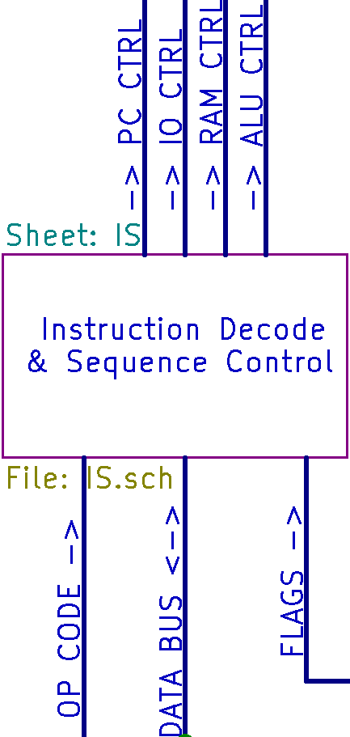
Figure 1: Relevant part of top level block diagram
The relevant sections of Ref 2 that define the signals used / provided by the IS are:
- 2.1 Overview of Data Bus
- 3.1 Common bus signals (not shown in Figure 1)
- 3.3 OP CODE bus
- 3.4 PC CTRL bus
- 3.5 IO CTRL bus
- 3.6 RAM CTRL bus
- 3.7 ALU CTRL bus
- 3.8 FLAGS bus

IS Inputs and Outputs
All the inputs to, and outputs from, the IS are listed in Table 1. Some names have been shortened for use as local names in this document.
Table 1: ALU Inputs and Outputs
Ref 2 Full Name | Local Name | Type
OPCODE BUS | OPCODE | Input
FLAG_S | FLAG_S | Input
FLAG_V | FLAG_V | Input
FLAG_N | FLAG_N | Input
FLAG_Z | FLAG_Z | Input
FLAG_C | FLAG_C | Input
DATA_BUS | DBUS | Input / Output
CLOCK | CLOCK | Output
READ | READ | Output
WRITE | WRITE | Output
SELECT_PC_DEST | SD_PC | Output
SELECT_PC_SRC | SS_PC | Output
SELECT_PNL_DEST | SD_PN | Output
SELECT_PVL_DEST | SD_PV | Output
SELECT_PNV_SRC | SS_PV | Output
SELECT_RAL_DEST | SD_RA | Output
SELECT_RAM_DEST | SD_RD | Output
SELECT_RAM_SRC | SS_RD | Output
ALU_MODE | MODE | Output
SELECT_ALU_DESTA | SD_AA | Output
SELECT_ALU_DESTB | SD_AB | Output
SELECT_ALUO_SRC | SS_AO | Output

The main reason for shortening the names is for convenience, particularly to avoid cluttering the block diagram shown in Figure 2.

IS Block Diagram
Figure 2 shows the level 1 block diagram for the IS.
<tbd>
Figure 2: TBD Level 1 Block Diagram
<tbd> Most of the signals on Figure 1 flow from left to right

Details for Each of the Blocks Shown in Figure 2
The following sub sections, one per block shown in Figure 2, define the function of each block.

<tbd>
The function of this block is to <tbd>
<tbd which is it>
This should be sufficient information for producing a schematic diagram for this part of the ALU without needing any further level 2 design.
This complex block will need a level 2 block diagram and further text to define the function of each block on that level 2 diagram.

References
- AVR Instruction Set Manual
- CpuDesign.docx

